**CTF Challenge: System Hacking**



**What is System Hacking?**

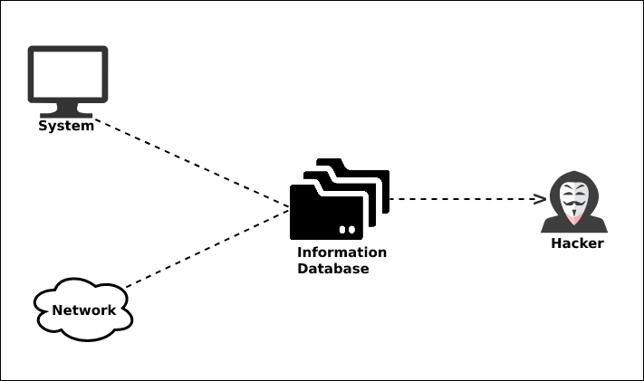

System hacking, also known as network hacking, is the process of gaining unauthorized access to a computer system or network. It's a double-edged sword, with malicious actors using it for harmful purposes and ethical hackers employing it for security improvements. Here's a closer look at its importance and description:

**Importance (Negative):**

* **Financial Gain:** Hackers often target systems to steal financial information like credit card details or bank account numbers, causing significant financial losses for individuals and organizations.
* **Disruption and Destruction:** Critical infrastructure like power grids or communication systems can be hacked, leading to widespread disruption and even physical damage.
* **Espionage:** Stealing confidential data for espionage purposes can compromise national security or give competitors an unfair advantage.
* **Data Breaches:** Hacking can expose sensitive personal information, such as medical records or social security numbers, leading to identity theft and other problems.

**Description of Techniques:**

Hackers utilize various methods to exploit weaknesses in a system's security:

* **Social Engineering:** Manipulating users into divulging sensitive information or clicking on malicious links through psychological tactics.



* **Phishing:** Sending emails or messages disguised as legitimate sources (banks, social media platforms) to trick users into revealing credentials or downloading malware.
* **Malware:** Installing malicious software on a system to steal data, disrupt operations, or gain unauthorized access. This can include viruses, worms, ransomware, and Trojan horses.
* **Exploiting Vulnerabilities:** Identifying and taking advantage of weaknesses in software, hardware, or configuration to bypass security measures and gain access.
* **Password Cracking:** Using brute-force attacks or sophisticated techniques to guess or break user passwords.

# **Capture the Flag (CTF) Challenges**

Flag 1.Process of gaining unauthorized access to a computer system or network

Answer: System Hacking/Network hacking

Flag Captured

Flag 2. What can lead Hacking critical infrastructure to widespread?

Answer: Disruption

Flag Captured

Flag 3. What Social engineering involves manipulating users to give up?

Answer: Information

Flag Captured

Flag 4. What Phishing emails often appear to be legitimate ?

Answer: Source

Flag Captured

Flag 5. Malware is a type of malicious software used to steal data or gain what? Answer: Unauthorized Access

Flag Captured